**Task 1: Basic Vulnerability Scan**

• **OBJECTIVE**

Task: Scan a network for vulnerabilities.

**Details:**

Use a tool like Nmap or OpenVAS to scan for vulnerabilities.

Review and interpret the scan results.

• **STEPS**

**Install Nmap:**

**1. Installing Nmap**

First, I made sure that **Nmap** was installed in my Kali Linux environment. I used the following command to install Nmap:

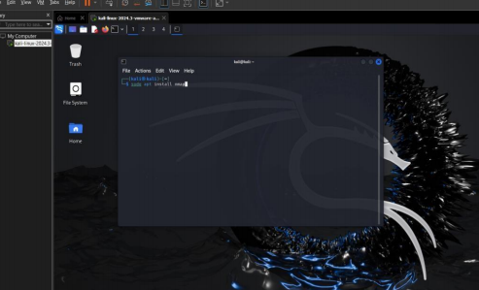

**Basic Nmap Scan Commands:**

**2.Basic Scan of the Target**

I initiated a basic scan of the target IP address to check for open ports and services:

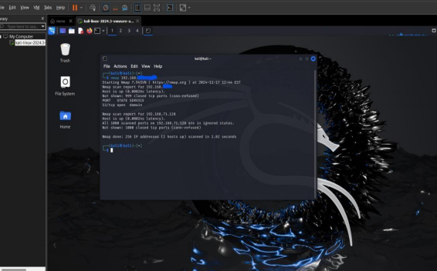

This command provided an overview of open ports and services running on the target machine.

**3.Service Version Detection**

To gather more details about the services running on the open ports, I used the -sV flag to detect service versions:

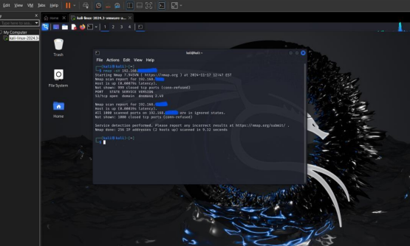

This step allowed me to identify the specific versions of the services, which could be crucial for identifying vulnerabilities.

**Vulnerability Scanning with Nmap Scripts:**

**4. Vulnerability Scan**

Finally, I performed a vulnerability scan using the Nmap **vuln** script:

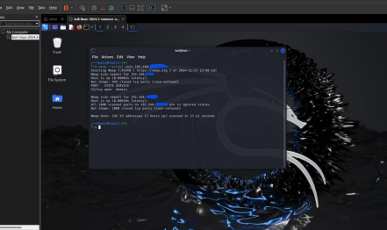

This script identifies known vulnerabilities in the services running on the target.